**Android Assignment 5 – Final Assignment**

* For those that manage to get this far, well done! The final task takes all of the elements of Android app development, and then some extra stuff you will need to investigate.

The final task is to develop a version of the *LightsOut* game. The rules are shown here

<http://en.wikipedia.org/wiki/Lights_Out_(game)>

(under the gameplay section, the rest is for interest only)

* Your version of the game should play the game as described above, but also provide an option menu that allows:
  + Resetting of the game to its initial position.
  + Restarting the game with a random setup of lights.
  + Undo one or more moves.
  + Change the level of difficulty.

Your game should look something like this below:



Figure : Basic play area

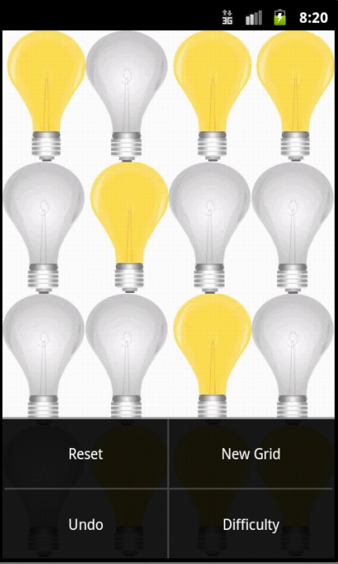

Figure : Option Menu